It focused on deploying and running the EduGenie Learning Assistant in a local development environment using FastAPI and Uvicorn. This activity ensured that the complete frontend-backend system was functioning correctly and could be accessed through a web browser for real-time interaction.
The application was executed locally using the following command:
uvicorn main:app --reload
The --reload flag enabled automatic server reloading whenever changes were made to the project files, making development and testing more efficient.
After successful execution, the application became accessible through the local server URL:
http://127.0.0.1:8000
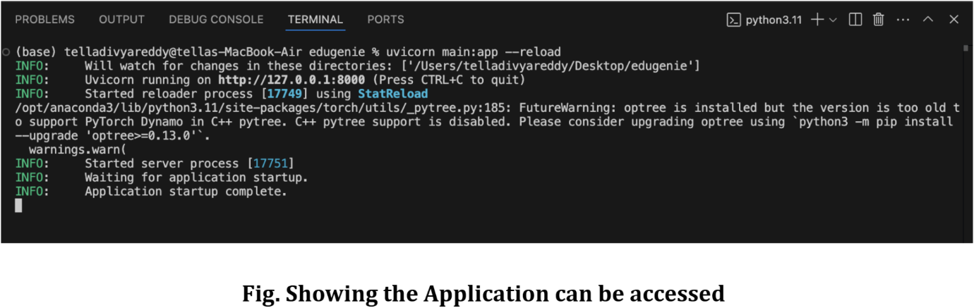
The image shown above illustrates the terminal output after running the application successfully. It displays:
Uvicorn server initialization
Local server address
Application startup completion
Live backend execution status
This confirmed that the FastAPI backend was running properly and ready to process educational requests from the frontend interface.
This activity successfully established the local deployment environment for EduGenie and enabled real-time testing of all AI-powered educational functionalities.

